TEAM ID: PNT2022TMID35083

Step 1: Connect the blocks

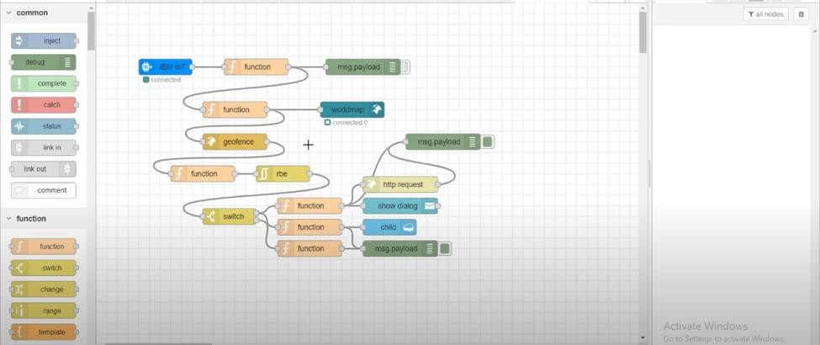

Step 2:Create python code

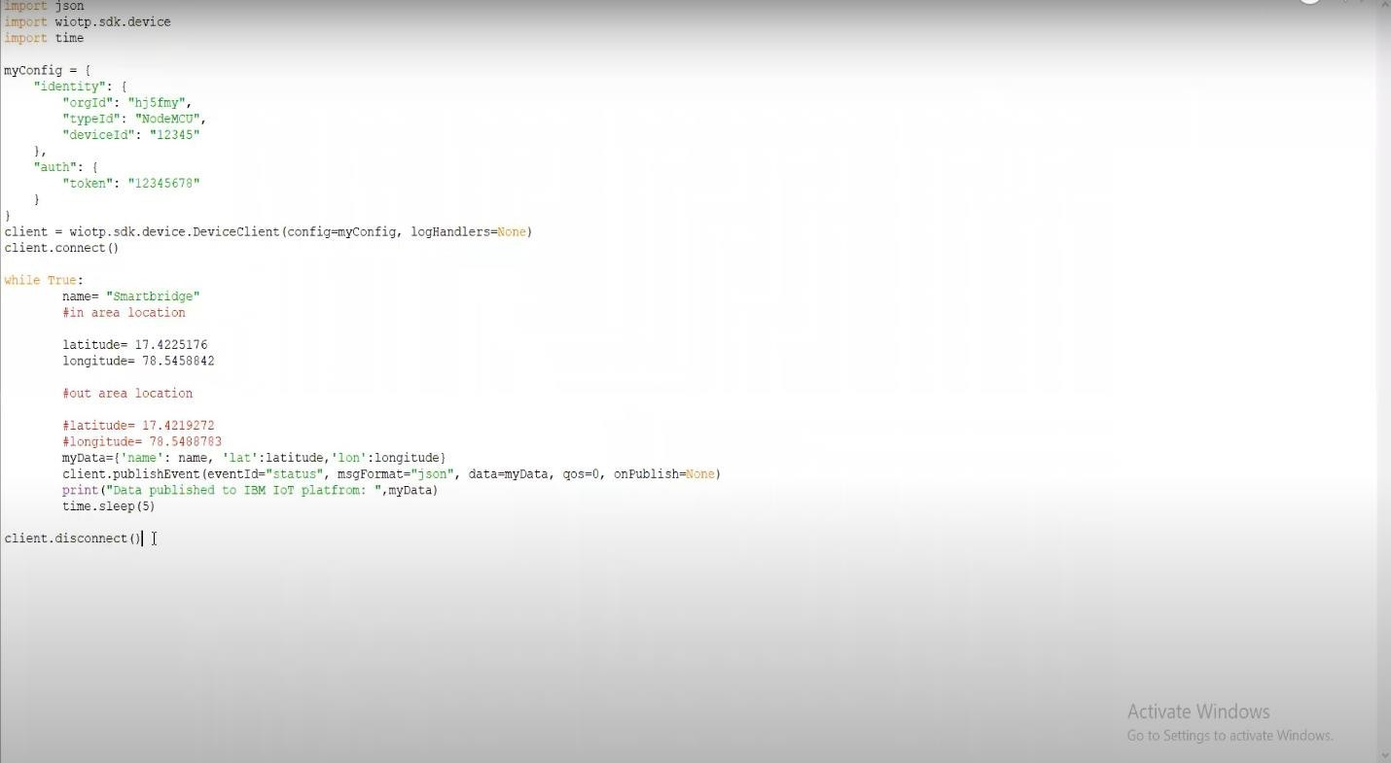

Step 3:Click the geofence node

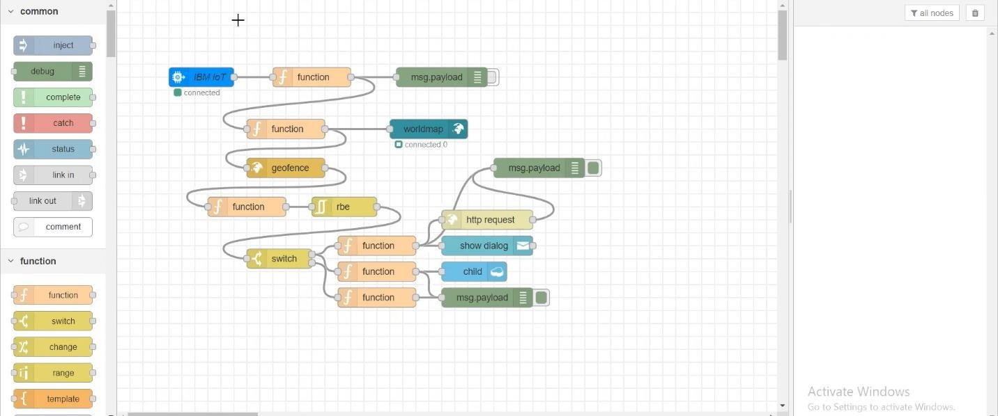

Step 4:Create the geofence area in the map

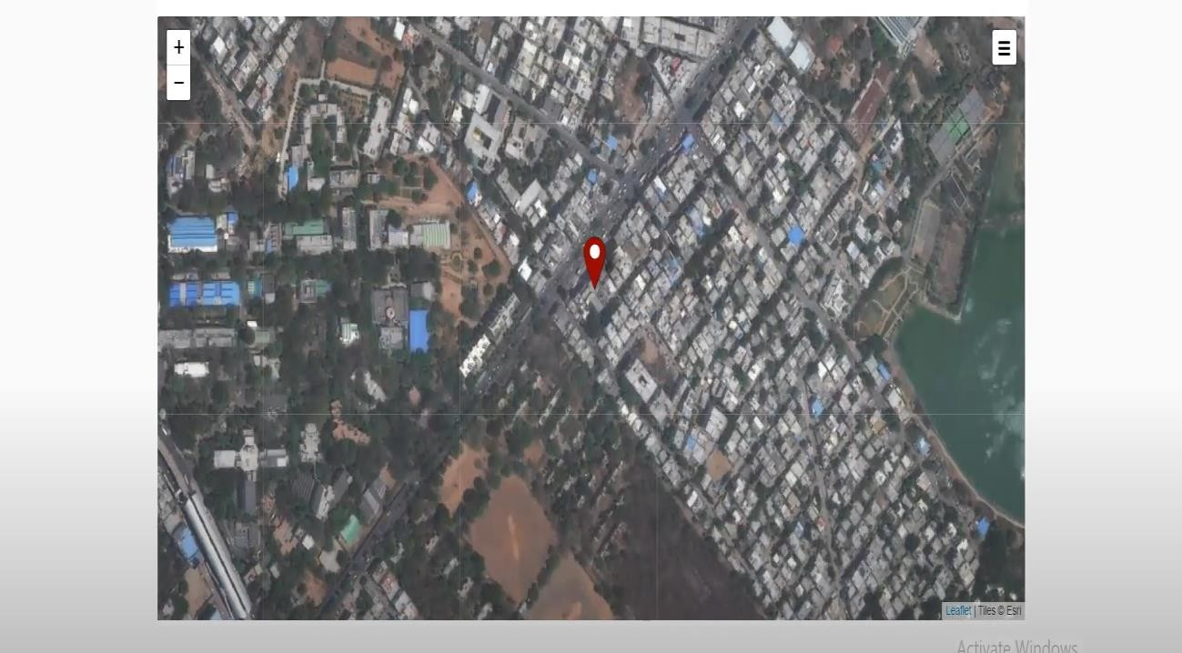

Step 5:Create geofence in a particular area

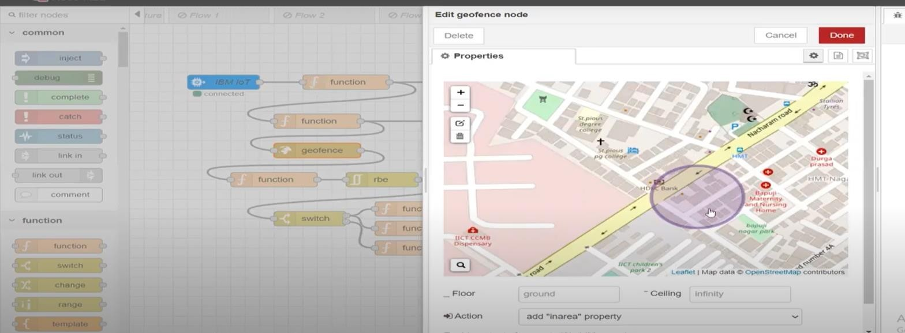

Step 6: Select the function block

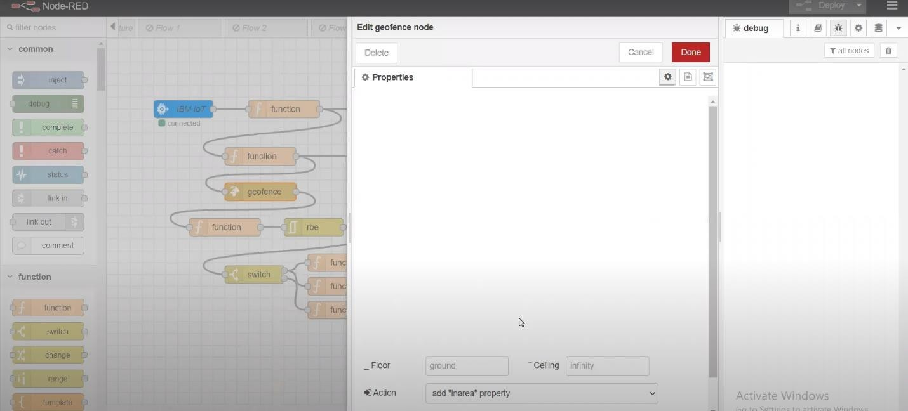

Step 7:Select the msg payload

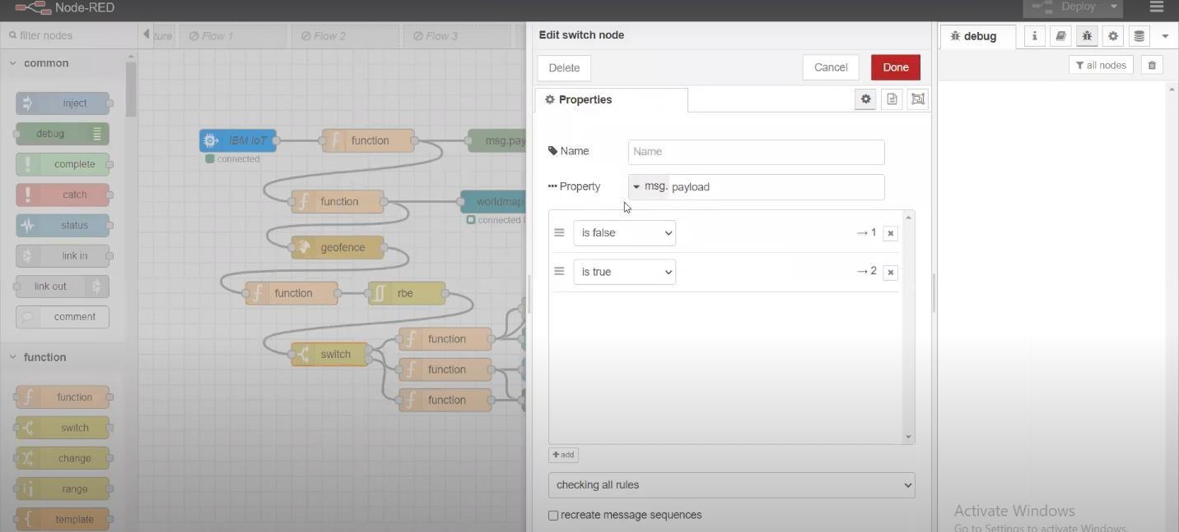

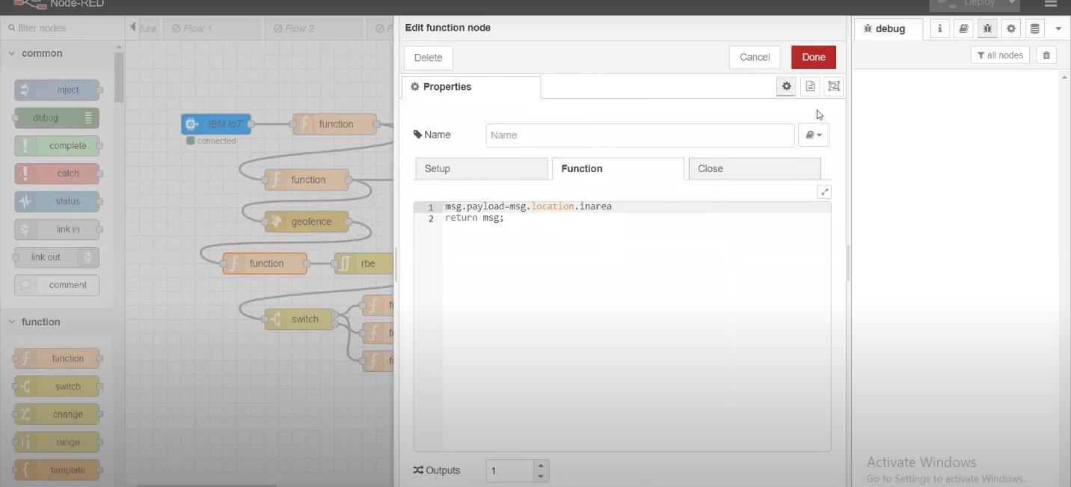

Step 8: To identify the person in area

Step 9:Select the http request to send msg to parent or gaurdian

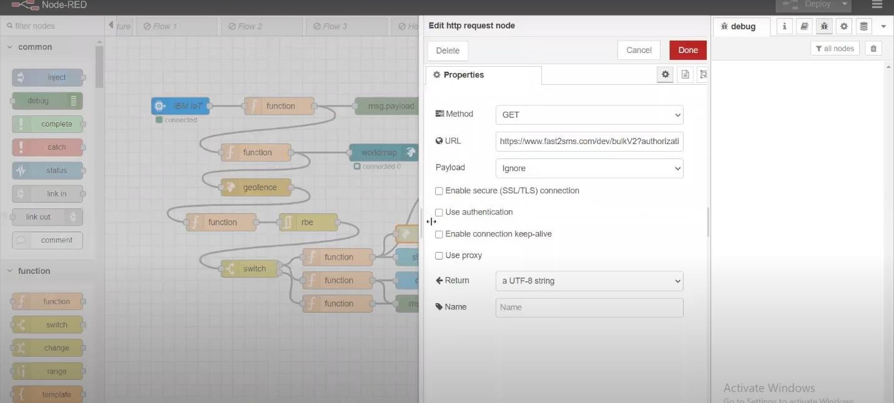

Step 10:For sending the msg with time

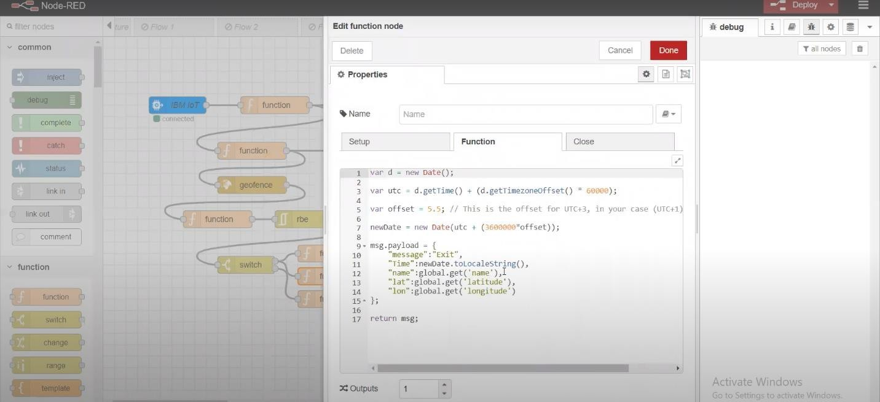

Step 10: Click show dialog for notifying the popup alert

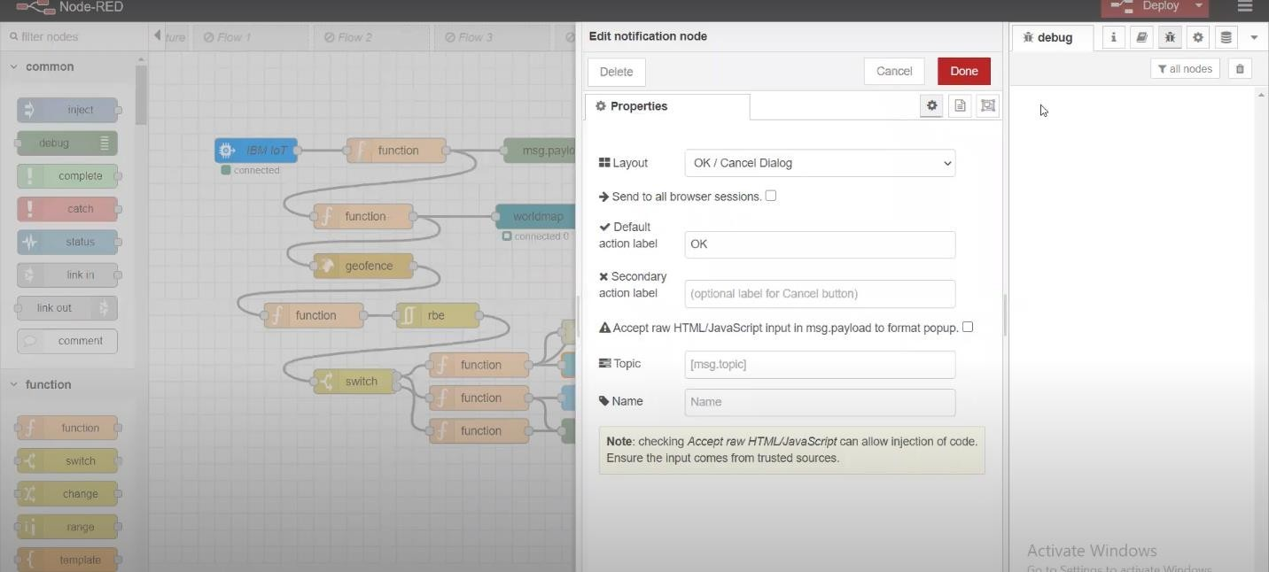

Step 11: Create another payload and to pass the data to geofence and worldmap

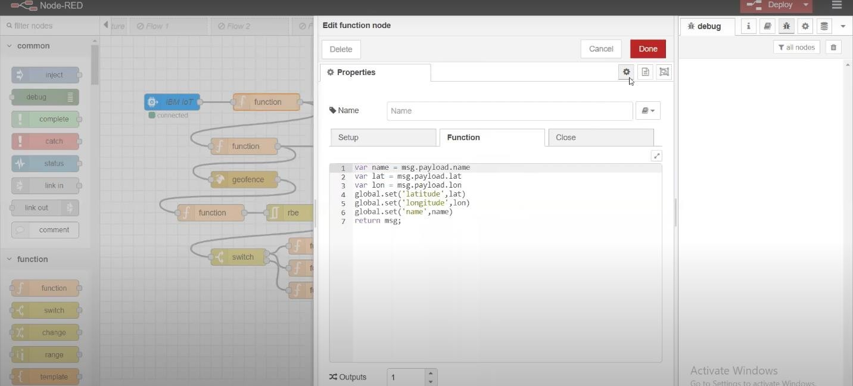

Step 12:Click the worldmap to see the location

